Guadalupe Flores

November 6, 2019

IT FDN 100 A

Assignment 05

Programming with Python Module 5

# Introduction

In the fifth segment were introduced to lists and dictionaries. The assignment includes storing and loading files and working with dictionaries.

# Webpages

In addition to reading the chapter, we were assigned to review several tutorial web pages from the website listed below, and the selection of Python tutorials are as followed:

Lists: <https://www.afterhoursprogramming.com/tutorial/python/lists/>

Dictionaries: <https://www.afterhoursprogramming.com/tutorial/python/dictionaries/>

Reading Files: <http://www.afterhoursprogramming.com/tutorial/Python/Reading-Files/>

# Applying our Knowledge

After reviewing the required reading, lecture notes, videos, and web pages, we then were required to complete an assignment by creating a “ToDo” file with two columns, “Task” and Priority.”

# Creating the Program Script

The objective of the assignment was to create a program that includes menu options lists and dictionaries script. See Figure 4.

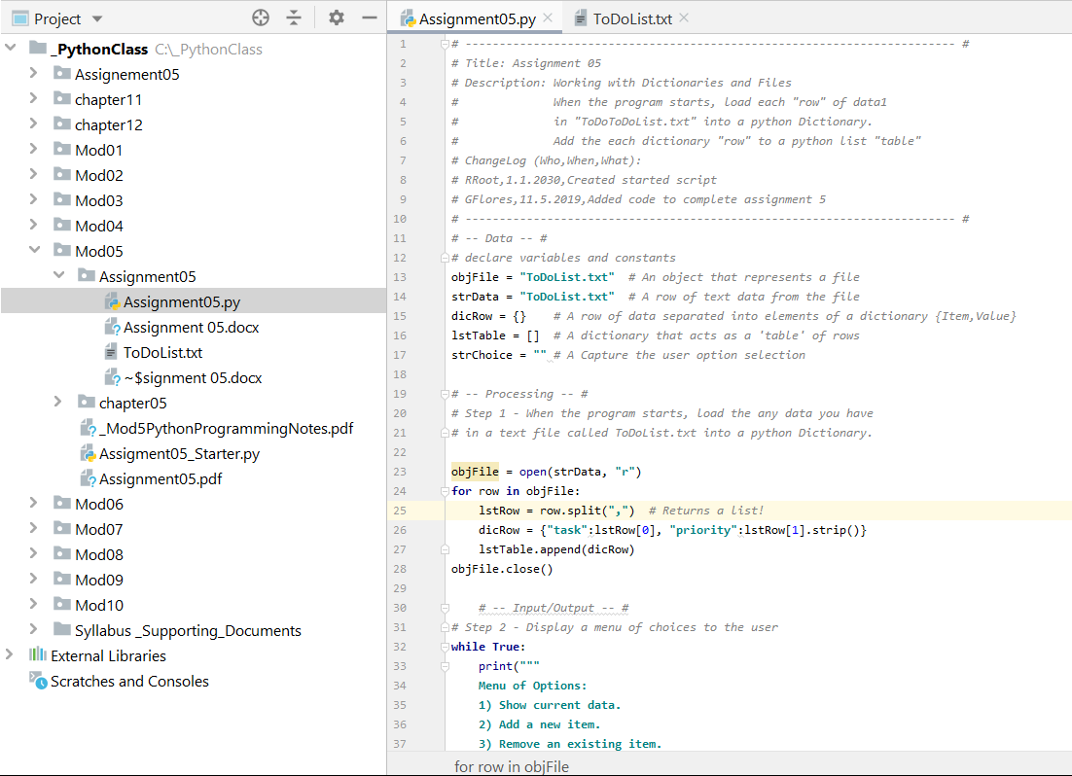

***Figure 4: Entering header information and codes in PyCharm***

# Running the Script

To test out your script in PyCharm select Run from the task menu. A lower console should open, with a Menu of Options. The user has five options. If the user selects “1) Show current data.” The program will show the current data and or “Add a new Item” or “Remove an existing item.” The program will continue to loop until the user’s selection of option ” Save Data to File” and or “Exit Program. See Figure 5. Also, our program included the function to create a text file and save it to Windows C: Drive. See figure 6.

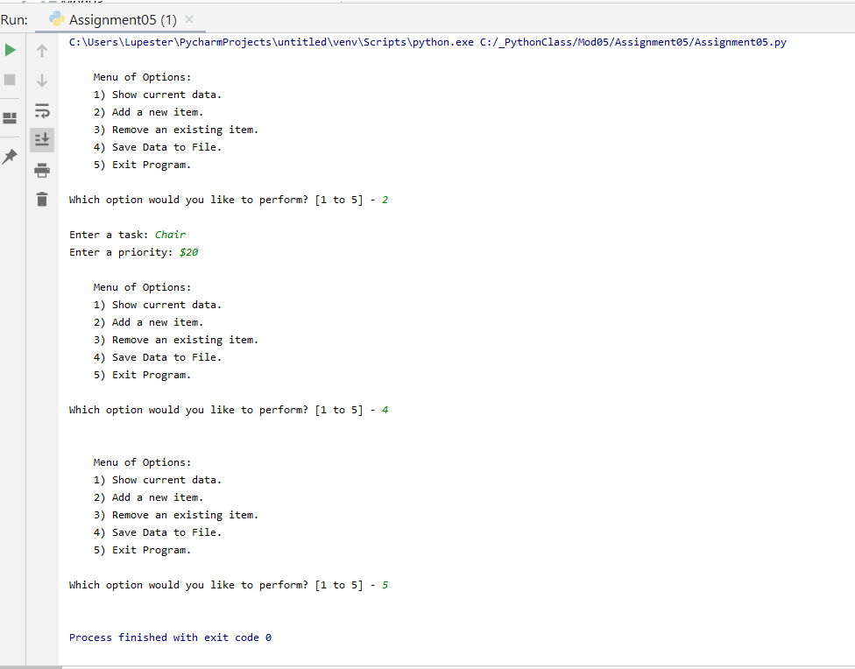

***Figure 5: PyCharm results of running the script shown in the bottom console***

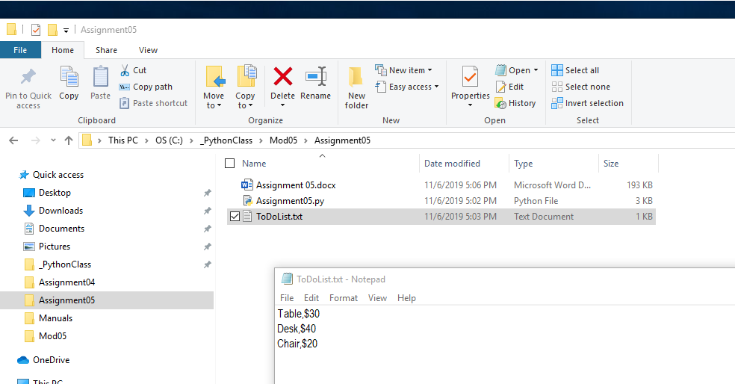

***Figure 6: To-do list Text file list.***

# Summary

In reading Chapter 5, and reviewing the lecture notes, webpages, practices running the lab assignment and reviewing the tutorials. Replicating the steps from assignment 4, I was able to create a subfolder, and a file, and essentially create a program loop that adds, display and stores the data results, saves it, and creates a text file.